Execute the following Queries by SQL COMMANDS

1. Show all data associated in salgrade table
2. Show deptno from dept table
3. Show 5% increment of salary from emp table for each of the employee (ENAME, SALARY, 5% INCREMENT)
4. Show the new salary after increment (from 3) for each of the employee in emp table
5. Show all the associated information of the employee named “BLAKE”.
6. Run the SQL COMMAND to show the following output

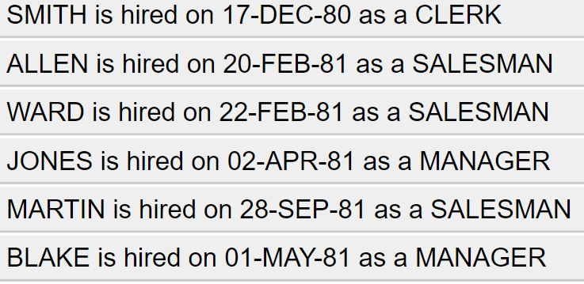

1. Show the description of all the four tables in the scott schema
2. Show all the possible jobs from the emp table eliminating the duplicate instances or output